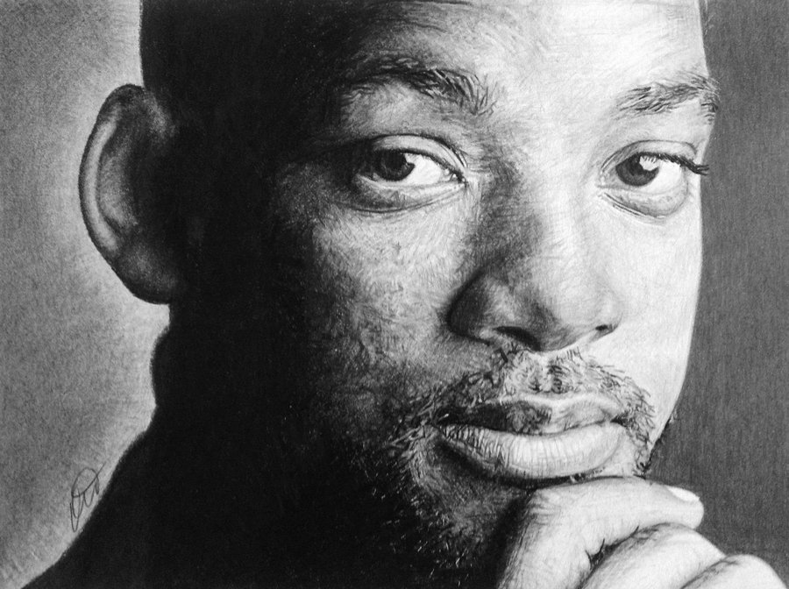

Draw an Arrow from at least 7 of the words below, pointing out examples of the meaning of these words in the drawing of Will Smith above.

**Line Accented Line Contour line Interior Line Texture**

**Value Positive Space Negative Space.**

Be Specific!! If I cannot tell what you are pointing to, you will not receive credit for your answer.